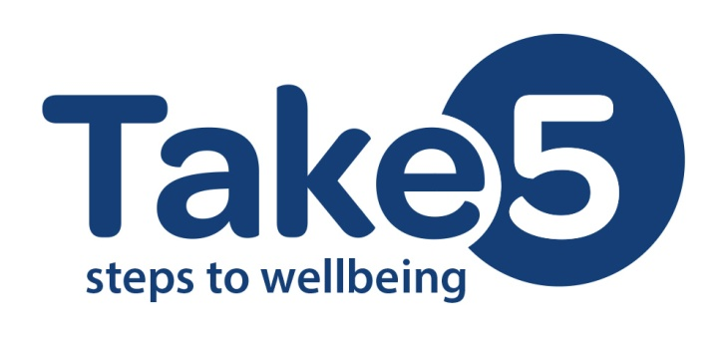

**Press Release**

**Wednesday 7 October**

**Take 5 steps to wellbeing and look after your emotional health**

Belfast Lord Mayor, Arder Carson, with the support of Belfast Strategic Partnership’s Mental Health and Emotional Wellbeing Thematic Group is encouraging Belfast people to look after their emotional health and ‘Take 5 steps to wellbeing’.

The BSP’s Mental Health and Emotional Wellbeing Thematic Group aims to raise awareness and enhance individual emotional resilience and wellbeing for Belfast citizens and help inform decisions about building emotional resilience for Belfast citizens. ‘Emotional resilience’ refers to an individual’s ability to adapt to stressful situations or crises.

The five steps to wellbeing are:

* Give
* Be active
* Connect
* Keep learning
* Take notice

Host of the Take 5 Interactive Day, Belfast Lord Mayor, Arder Carson, said:

**“Belfast City Council is committed to helping make Belfast a healthier city. One way to do this is to encourage those who live and work in it to look after their own health, mental and physical.**

**“Today’s event gives you some idea of the type of things that can make a difference and I hope everyone will give them a try. We all have to work together – good health impacts not just on the individual but it has an economic and social impact too, and for this reason it is important for councils to get involved.**

**“We are working with statutory, community and voluntary organisations because by working together to improve the health of people in Belfast we can produce wider benefits for the city.**

**“The facilities that can be found at our leisure and community centres are first class and offer a wide choice of activities to enjoy,” said the Lord Mayor.**

**“Take a chance and try something new; who knows where it might lead – a new interest, new friends, a feeling of wellbeing -and that will be worth it to you.”**

Speaking at the Take 5 Interactive day, Irene Sherry, co-chair of the BSP’s Mental Health and Emotional Wellbeing Thematic Group, said:

“We know from our consultation findings in the ‘Building Emotional Resilience Strategy 2014-2017’ that there is a need to develop a focused and life course approach to Mental Health in Belfast.

“Mental wellbeing can mean lots of different things, and many factors can influence our wellbeing but for most of us it means feeling good about ourselves, our lives and the community around us.

“We hope that people will come away from this interactive ‘Take 5’ event today with some ideas about how they can improve their mental wellbeing.

“We know from all the great work being done already by groups and agencies right across the city that people want to feel well. Health is everyone’s business and will take action from all of us. This collaborative event supports this vision and is a fun way of saying take time out for yourself: connect with others, get active, learn a new skill, volunteer or take notice of the world around you. Your mental health and physical health will undoubtedly feel the benefits.”

For further information about the Take 5 steps to wellbeing visit: www.makinglifebettertogether.com/emotional-resilience

**ENDS**

**Further Information:**

For further information about the Take 5 steps to wellbeing email: [jim.morgan@bhdu.org](mailto:jim.morgan@bhdu.org) or telephone: 028 9050 2073.

**Media enquiries:**

For further information contact Debbie McGrory, Communications Officer on 028 9050 2073 or email [Debbie.mcgrory@bhdu.org](mailto:Debbie.mcgrory@bhdu.org)

**Notes to Editors:**

1. The Belfast Strategic Partnership was established in February 2011 to address inequalities in health, which are significant across Belfast and can be mapped against deprivation indicators. It is a multi-sectoral partnership with the Belfast Health and Social Care Trust (BHSCT), Belfast City Council (BCC) and the Public Health Agency (PHA).
2. The BSP’s Mental Health and Emotional Wellbeing Thematic Group’s

(MHEWBTG) primary function is to develop and roll out a Building Emotional Resilience Strategy and action plan for the city of Belfast. The MHEWBTG, supported by the Belfast Health Development Unit, will take responsibility for the successful implementation of the strategy.

1. ‘Emotional resilience’ refers to an individual’s ability to adapt to stressful situations or crises.
2. In 2014, the BSP’s Mental Health and Emotional Wellbeing Thematic Group launched a consultation: ‘Building Emotional Resilience Strategy 2014-2017’. To view this consultation visit: www.makinglifebettertogether.com/ emotional-resilience
3. For more information on Take 5 visit: www.makinglifebettertogether.com/emotional-resilience

**Photo caption:** Hands up for the 'Take 5 steps to wellbeing' campaign - Lord Mayor, Arder Carson, shows his support for the event at Belfast City Hall organised by the Belfast Strategic Partnership’s Mental Health and Emotional Wellbeing Thematic Group encouraging everyone to take care of their wellbeing and emotional health. Pictured with the Lord Mayor are speakers and organisers from the groups involved in the partnership including Belfast Health and Social Care Trust and the Public Health Agency.