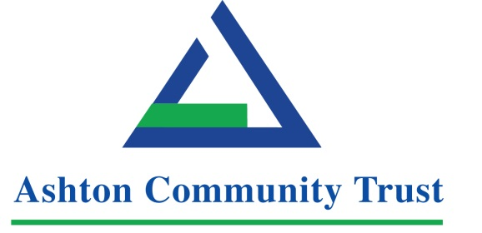

north Belfast Social enterprise collects Ireland Excellence Award

Press Release: Thursday 28 January 2016

Ashton Community Trust has been awarded the EFQM Ireland Excellence Award at a prestigious ceremony in Bangor.

The award winning social enterprise and development trust based in North Belfast, received the accolade at the Centre for Competitiveness organised event in the Clandeboye Lodge Hotel on Thursday January 28, 2016 alongside Friends First, which has 276,000 customers and manages assets worth €4.7billion.

The Ireland Excellence Award is the top level of recognition available in the highly-regarded scheme, which is supported by the Department of Finance and Personnel, Capita, and NIE Networks.

Ashton Community Trust is a provider of education, training and employment. It supports the development of social enterprises, provides childcare, and promotes and provides health and wellbeing, culture and arts, and youth provision. It has made a huge impact in North Belfast and indeed across the city by creating over 170 jobs, providing vital and important services and being at the forefront of community development for the last 25 years.

Chief Executive of Ashton Community Trust Paul Roberts said this latest EFQM award was a fantastic achievement for the organisation.

“Over the last seven years Ashton has proactively engaged with the EFQM framework and its assessors and has risen through the ranks to achieve this Ireland Excellence Award,” he said.

“This latest award is credit to the hard work and dedication of all our staff, board members, staff and volunteers. Without their commitment we wouldn’t be able to achieve our mission of making North Belfast a better place to live. Over the years we have strived to build the quality of our services but what continues to be at the forefront of all of our efforts, are local people.”

Head of Corporate Services Ciara Rea, who picked up the award on behalf of Ashton Community Trust at the event today, added:

“We feel very privileged to work for the community. A lot of our staff come from the local area and this is one of Ashton’s key strengths that ensures we are connected on the ground and understand key issues that are affecting everyday life, be it health, employment, job skills, child care, families, the legacy of the conflict, young people, culture, digital technologies, cross community relationships or education.

“We strive to support people in all of these areas, and to do it well. And I’m delighted to say that people who use our services tell us we are making a difference and we are helping and supporting them to create positive opportunities in their lives.”

CforC Chairman, Stephen Kingon, said: “This year’s award recipients represent a range of industries and sectors, but they all have a commitment to ensure excellence is an integral part of what they do, so I warmly congratulate them on their achievements.

“There are many advantages for organisations in taking part in the Ireland Excellence Awards process, and by passionately pursuing quality excellence they become leaner, more profitable, more sustainable and therefore more competitive,” he adds.

In total this year, 20 organisations received awards of various levels of recognition. Other winners included Bradfor Ltd of Rostrevor and IPC of Carrickfergus, who both manufacture equipment used in the aerospace industry, as well as Balloo Inns and fonaCAB.

Winners undergo rigorous examination and must illustrate their employees’ dedication, low absenteeism, high productivity, customer satisfaction and superior financial performance.

Established by the private sector, the Centre for Competitiveness (CforC) is an independent, not-for-profit membership organisation, dedicated to actively supporting the development of an internationally competitive economy through innovation, productivity improvement and quality excellence in the private, public and voluntary sectors and to build best in class performance through International Leadership across all sectors.
The Ireland Excellence Awards process is based on the world class EFQM Excellence Model, incorporating different levels of recognition.
Since 1991, over 30,000 European organisations, large and small, from the private, public and voluntary sectors have used the EFQM Model as their blueprint and driver of competitiveness.
Levels of recognition include: Ireland Excellence Award, Recognised for Excellence EFQM 5 Star, 4 Star and 3 Star Awards, Committed to Excellence, and the EFQM Gold Star Service Excellence.

The Awards are not an end in themselves but a means of assessing and recognising role model organisations against the most rigorous international quality standards while encouraging management and staff to continue their excellence journey to the next level.

ENDS

More details about Centre for Competitiveness here:
www.cforc.org

Media contact:
Chris Harrison, JPR: 028 9076 0066, 077 6641 7550 or chris.harrison@jprni.com

Notes to Editors

Ireland Excellence Award winners
- Ashton Community Trust
- Friends First

Excellence 5 Star Award
- Lake Hotel Killarney
- Killarney Convention Centre

Excellence 4 Star Award
- Crowne Plaza Dundalk
- Pembroke Hotel, Kilkenny
- Tourism NI
- NI Housing Executive
- RQIA

Excellence 3 Star Award
- Bradfor Ltd
- IPC

Committed to Excellence
- Skylon Hotel Dublin
- Westport Woods
- Waterfront Hall

Gold Star Service Excellence
- Sign & Digital
- Brain Injury Matters
- Foyle Women’s’ Aid
- Balloo Inns
- Helm
- fonaCAB

