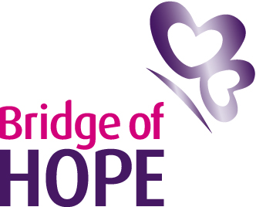

Press Release April 8 2011
Event: Bridge of Hope ‘Rises’ to the Challenge

The Belfast based victims and survivors family support service group Bridge of Hope is throwing its support behind a campaign being launched by singer turned therapist Frances Black.

The all-Ireland campaign, launched in the Shelbourne Hotel in Dublin today, centres around the charity that Frances from the famous singing Black family set up to provide help, support and professional counselling services to the families of those who are in addiction.
The awareness drive of Frances' charity The RISE Foundation is coupled with a fundraising effort to raise £1.5 million to build a new centre on Rathlin Island off the coast of County Antrim.
As part of the awareness week, that starts today (Friday April 8), a CD of songs is being released with songs from Snow Patrol, U2, Brian Kennedy and Christy Mooore alongside a book of personal stories about addiction from everyday families as well as celebrities such as singer Mary Coughlan and footballer Paul McGrath.

Just this week planners from the Department of the Environment in Stormont gave the Rise Foundation’s development on Rathlin Island the green light.

Bridge of Hope has worked collaboratively with Frances Black and the Rise Foundation in recent years, sending families and community practitioners for education and awareness programmes.

The centre offers understanding and advice around all sorts of addictions including alcohol, drugs, and gambling.

Speaking about the launch of RISE awareness week Bridge of Hope Head of Victims Services Irene Sherry said she hoped the public got behind the campaign.

"This is such a worthwhile cause. Addiction is a massive issue affecting our society and we know all too well the damage particularly alcohol abuse is costing us. In North Belfast alone we know it’s a huge concern and that many families have sought help and support around this issue.
“The book that accompanies this campaign 'You Are Not Alone' is a book of inspirational personal accounts and letters, both by those in recovery from addiction and loved ones impacted by it. The songs gathered together also represent hope for a better future. Taken together we hope this campaign gathers momentum and highlights the important work being done to support families impacted by addiction.”

Notes to Editors
The RISE Foundation Awareness Week runs from April 8-15 2011.
More details can be found on www.therisefoundation.ie
For more information please contact Irene Sherry from Bridge of Hope 028 90746737 or Mark O'Doherty from the Rise Foundation T: + 353 1 764 5131

